JOB NO:01

Job Name: Use of html Heading, paragraph image, bold, horizontal

Input: All html tag

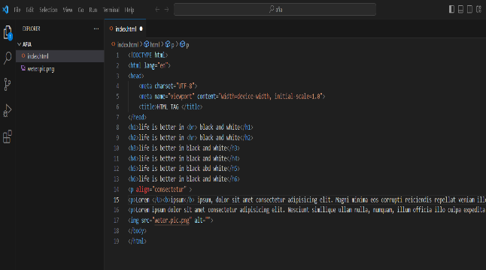

Heading tag , br tag and hr tag input:

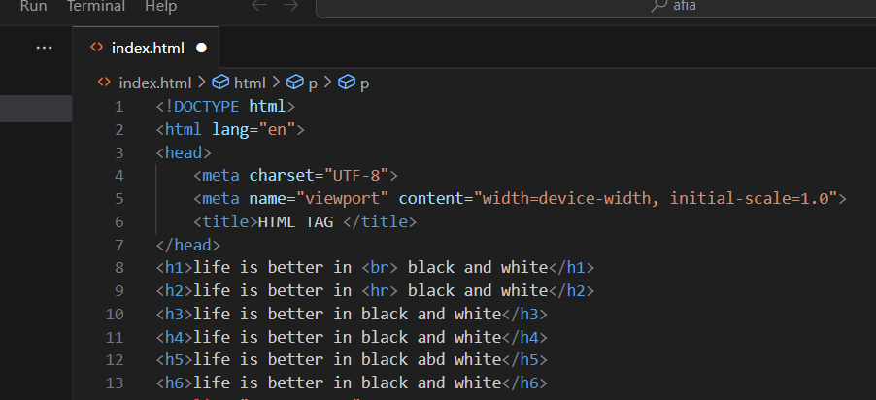

Pearagraph tag (:lorem,bold,center,align)and Image tag input: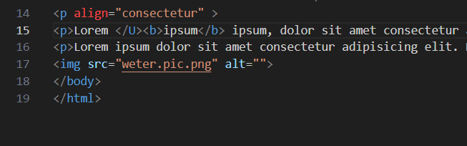

Output :Html all tag

